use company;

create table Sales(

saleid int primary key auto_increment,

productid int,

customerid int,

saledate date,

quantity int,

unitprice int,

region varchar(20));

insert into Sales(productid,customerid,saledate,quantity,unitprice,region)

values(101,1001,"2024-01-05",5,200,"North"),

(102,1002,"2024-01-10",10,150,"East"),

(103,1003,"2024-02-15",2,300,"North"),

(104,1004,"2024-02-20",7,250,"West"),

(101,1005,"2024-03-05",1,200,"East");

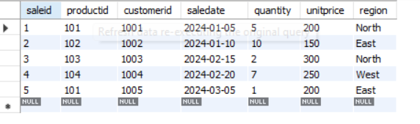

# Q1- Query to calculate the total sales (Quantity * UnitPrice) for each product.

Select productid, Sum(quantity*unitprice) As 'Total Sales' from sales group by productid;

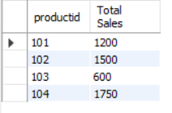

# Q2- Query to find the total number of products sold in each region.

Select region,sum(quantity) AS 'Total Product Sold' from sales group by region;

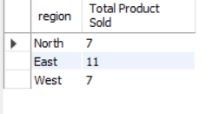

# Q3- Query to get the average sales amount per product.

Select productiD,avg(quantity*unitprice) AS "Average Sales" from sales group by productid;

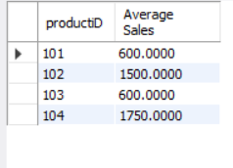

# Q4- Regions where total sales are more than 3000.

Select region, sum(quantity*unitprice) AS "Total Sales" from sales group by region having sum(quantity*unitprice)>3000;

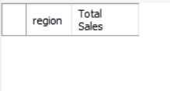

# Q5- Query to get the maximum quantity sold for each product.

Select productid,max(quantity) AS "Maximum Quantity Sold" from sales group by productid;

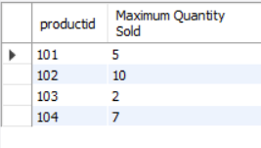

# Q6- Query to calculate the average quantity of products sold per region.

Select region,avg(quantity)from sales group by region;

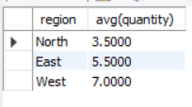

# Q7- Find the product IDs that have generated a total sales amount of more than 1000.

Select productid, sum(quantity*unitprice) from sales group by productid having sum(quantity*unitprice)>1000;

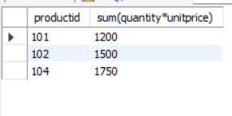

# Q8- Query to get the total number of sales (rows) made for each customer.

Select customerid, count(*) As "Total Sales" from sales group by customerid;

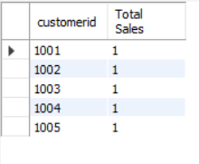

# Q9- Find the products for which the average quantity sold is less than 5.

Select productid , avg(quantity)from sales group by productid having avg(quantity)<5;

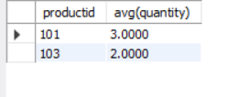

# Q10- Query to find the sum of total sales for each customer in each region.

Select customerid,region, sum(quantity*unitprice) AS "Total Sales" from sales group by customerid,region;

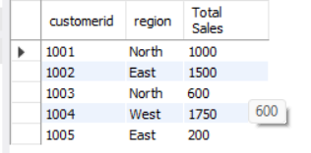

# Q11- Query to calculate the total sales for each month.

Select month(saledate), sum(quantity*unitprice) AS "Total Sales" from sales group by month(saledate);

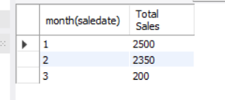

# Q12- Find the regions where the average unit price is more than 200.

Select region,avg(unitprice) from sales group by region having avg(unitprice)>200;

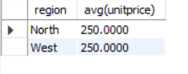

# Q13- Query to get the minimum and maximum quantity sold per region.

select region, min(quantity) as "Minimum quantity sold",max(Quantity) as "Maximum Quantity Sold" from sales group by region;

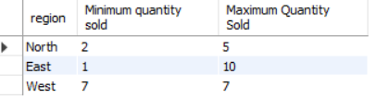

# Q14- Find the customers who have made more than 2 purchases.

select customerid from sales group by customerid having count(*)>2;

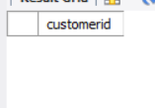

# Q15- Query to find the total sales for each product and filter only those products where the total sales exceed 1500.

Select productid, sum(quantity*unitprice) as"Total Sales" from sales group by productid having sum(quantity*unitprice)>1500;

